Newsletter 🏶 August 2023
New Zealand
RED DEVON
Cattle Breeders Association

Welcome to the August Newsletter

AGM Report from the Chair

The AGM was held on 27th May at the Solway Park Hotel in Masterton. The attendance at the meeting was somewhat disappointing with only around 10 present in person and a few utilized the zoom facilities organized for those unable to travel.
The agenda items of interest were nominations by council for life membership for David and Sue Dreardon, who have just dispersed their longstanding Pencarrow Stud and also Arthur Beasley whose Tapuwae cattle are represented known in associations worldwide. Both the Dreardon’s and Arthur were involved in establishing the NZ Association many decades ago and have been active members, serving on council in the past. Their nominations were unanimously accepted.
The options for the Association going forward were discussed and it was agreed to further investigate if efficiencies of scale could reduce costs by a closer working relationship with Australia, this wasn’t properly advanced last year as our Association deliberated on whether to renew our ABRI contract on similar terms.
Changes to council saw both Danielle Boven and Maggie Hutchinson stand down and Lesley Holdstock elected, Jarred, Stephen, Dirk and myself continue for another year. We are still a council member short if anyone wants to assist.
The meeting was followed by a visit to Warrick Gardner’s Headley Downs Stud where we viewed approximately 40 cows with calves at foot and 2 stud sires, thank you to Warrick for the opportunity to view those. Returning to Solway Park an evening meal was enjoyed by all attending.

Heughan

Ellesmere Stud report

Hello from Ellesmere Stud in Mid Canterbury - Banks Peninsula.

Something a little different to report about which could prove
interesting to some Red Devon breeders and maybe then encourage
participation.

Originally we had sort of planned to enter in the Virtual Beef
Competition for the Easter of 2022, can't remember why we didn't proceed
- most likely a time thing....but come late February 2023 when entries
needed to be in by we decided yes we'd give it a go. One of the rules is
all stock entered must be registered.

We entered two Red Devon yearling heifers from Ohuka Stud, one Red
Devon homebred two year old heifer and a Red Devon cow with calf at foot
- a bit ambitious - but we reckoned we'd see how things go, & can always
leave the cow and calf out if needs be.
Halter training in progress
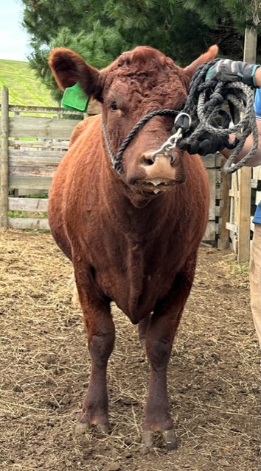

The Virtual Beef Competition is run by CAAPA - Canterbury A & P
Association, mainly brought about because of cancellations of the
November shows due to the lockdowns.

OHUKA VJA WT II (misspelt below) out of Ohuka Jasmine and Tinopai VJ Awhitu
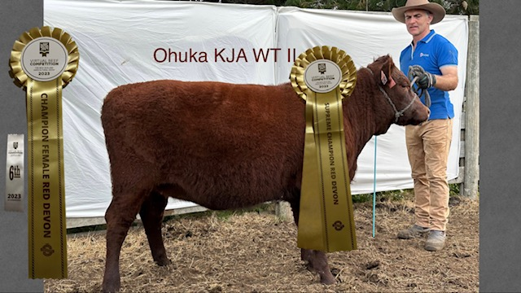
So we had about 6 weeks in which to handle as in to start touching,
grooming, halter training, teaching to walk while being led & bathing
these 5 cattle. First thing was to group them together in a smaller
area and feed them everyday with baleage and brewers grain ( which we
had unlimited access to ) within about a week they were hooked on the
grain which was a good start...then in the yards with them all to get
used to being touched and then brushed - and that was brushing of all
these cattle for many hours !....it was reasonably easy placing the
halters on them - in the crush to begin with. One yearling and the 2 yr
old took to the halter really well, but the second yearling did put up a
fair amount of resistance to taking the halter off again as she was not
over keen for you touching around her head, so a lot more work stroking
and brushing her head and neck was required then resulting in better
acceptance of the removal of the halter....we spent quite a few weeks
with a couple of hours work each day with an occasional day off for them
, working on these three cattle ( we decided to drop out the cow & calf
due mainly to so much time needed on each of them, plus the weather came
in very windy & wet which set us back many days ) ...walking was
interesting for one of the yearlings as she preferred to bunny hop
particularly on a long stretch of walking, and this didn't change for
her throughout the weeks either. Standing still without fidgeting they
were all good at - which they have to do for the photos and
videoing....walking off when on their own proved more problematic
because as they had no others to follow getting them to strike off to
start was not easy - this again is required for the videoing part to
show - front, back, both sides, walking away & then walking back....we
did resort to bribery by using a bowl of food at each end of the yard to
encourage the walking, although this could end up up as a speed walk,
but at least this did get them moving. Another 1 or 2 days more of work
would have been beneficial for us then we could have really fine tuned
nicely, but there is a set time to submit the finished photos and videos
which is I think 4pm on Easter day.
Ellesmere Riverton out of Ohuka Pride and Mt Te Uku Marsha 588
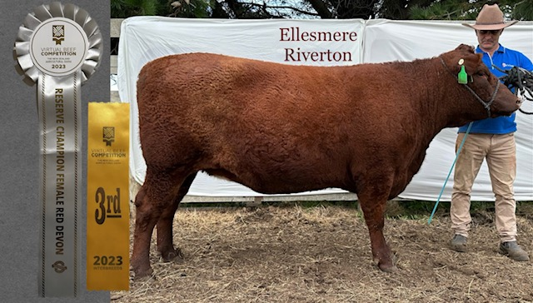
We did our best and that includes the three cattle as well, and we were
delighted to find that our homebred 2yr old - Ellesmere Riverton - had
gained a 3rd placing in the Interbreeds Section and Reserve Champion in
the female Red Devon section. And Ohuka VJA WT 11 was placed Champion
female Red Devon....all 3 Devons competed against each other in the Red
Devon section as ours were the only ones entered.

It was a lot of fun, also certainly plenty of hard work for us all, more
so as we had 3 cattle to work on. I'm fairly sure by the end of the
final day Jonathan came away with quite a few bruises as he was the sole
person showing them... would we do this again ? most definitely, maybe
we'll need to break them in when the cattle are a bit more on the
younger side, possibly when in the yards for weaning - although saying
that we just pulled the 2yr old out of the field and she was not fazed
at much at all, and was pretty easy to do most that we asked of her, so
you never know !!

As I understand there is most likely to be another Virtual Beef
competition for the 2024 year, with possibly there just being a photo
competition - as videoing like we found was a bit problematic.

Anyway that's all from us at - Ellesmere Red Devon Cattle Stud.
Thanks for reading !!

COUNCIL:

Heughan Gordon |  | Ph. 027 874 6195 |  |  |  | hcgordon@xtra.co.nz
Dirk Sieling |  | Ph. 021 154 0123 |  |  |  | dirk@sieling.nz
Lesley Holdstock |  | Ph. 03 329 0093 |  |  |  | trev_holdstock@yahoo.com
Jarred Sircombe |  | Ph. 027 485 2733 |  |  |  | mmreddevon@gmail.com
Vacancy
Stephen Harris |  | Ph. 07 880 9955 |  |  |  | savkharris@yahoo.co.nz
 | Lindy Lawrence |  | Ph.:  Mail:  e-mail: | 06-323 4484 / fax: 06-323 3878  PO Box 503, Feilding.4740  lindy@pbbnz.com


Members List (click here)

Important Dates to Remember
30th September | Annual animal pre-list dam fees invoiced
31st December | Balance Date; end of financial year
31st January | Calf entry sheets cut off
30th April | Membership Subscriptions Invoiced
May 2023 | AGM
30th June | Animal Disposal List (ADL) sent out
30th July | Deadline to return ADLs, by post or email to Linda Rule at PBB lindar@pbbnz.com  Please note no cow credits for ADL’s returned after the 15th August
10th August | Calf Entries start
2nd of every month | Group Run Cut off for the performance recording reports
www.reddevoncattle.co.nz

