Newsletter 🏶 February 2024
New Zealand
RED DEVON
Cattle Breeders Association

Welcome to the first Newsletter of 2024

The weather has overall been a vast improvement on this time last year, although some parts of the country are getting quite dry now. Most people have harvested their supplementary feed and pasture covers are mostly quite good. The slump in cattle prices appears to be lifting on a grass market so things could be a lot worse. The forecast dairy payout is slowly creeping up. The economy may take a bit longer to improve and interest rates may stay too high for many farmers’ comfort for a while.

AUSTRALIAN CONNECTION, DNA and AGM

Heughan has continued to be in touch with the DCBSA about a closer working relationship. One problem has been the incompatibility of our herd registers. ABRI have advised us that they are working on a new operating system that would make integration of the 2 registers a breeze compared to the existing systems. Our relationship with the Australian breeders will be discussed again at our upcoming AGM. At our AGM we will also be discussing compulsory DNA testing of all herd sires, this is what most breed societies have and is important for the integrity of our breeding. There is a small cost however but it is the range of tens of dollars rather than hundreds. We would like your feedback, especially if you don’t intend to attend the AGM. Speaking of which, we are still considering a venue combined with a nearby stud visit, so any ideas are welcome. Contact one of us on the below contact details.

SEMEN TEST UPDATE

The testing of semen for MBOVIS has been slow as dairy bulls are receiving priority and now the eradication. Stephen Harris has 4 batches waiting to be tested. Red Devon Semen cleared to date:

From Animal Breeding Services: Gowan Ross Gentleman and Vix Jurasic,

From S.T. Genetics: Tilbrook Prince (owned by your association) and Cutcombe Jaunty

The cut off date for testing is June, any semen not used or tested by then will have to be destroyed.

SHOW CATTLE

The association has decided to take up membership of the Royal Agricultural Society of NZ which will allow our members to showcase their cattle, so please feel encouraged to do so. Our wonderful breed needs more exposure.

SALE UPDATE

Countrywide recent sales: In calf registered cows $1600, R1 heifers $ 1000, R2 heifers $ 1200 to 1400, R2 bulls $2150 to $2450. Commercial 15 month bull $1850. A couple of registered cows with bull calves at foot went for $1350 per unit, but that was an aberration on the low side.

FOR SALE

Manawa Toru near Katikati is ceasing to operate as a stud and Logan Craft is selling his Te Maewa bred bull, 170718351. This has been his main stud sire and he is for sale for $ 3500 + GST, a quiet and well structured horned bull. Interested breeders can phone Logan on 0212141434. All the female stock have been sold apart from 1so far unregistered heifer calf sired by 351.

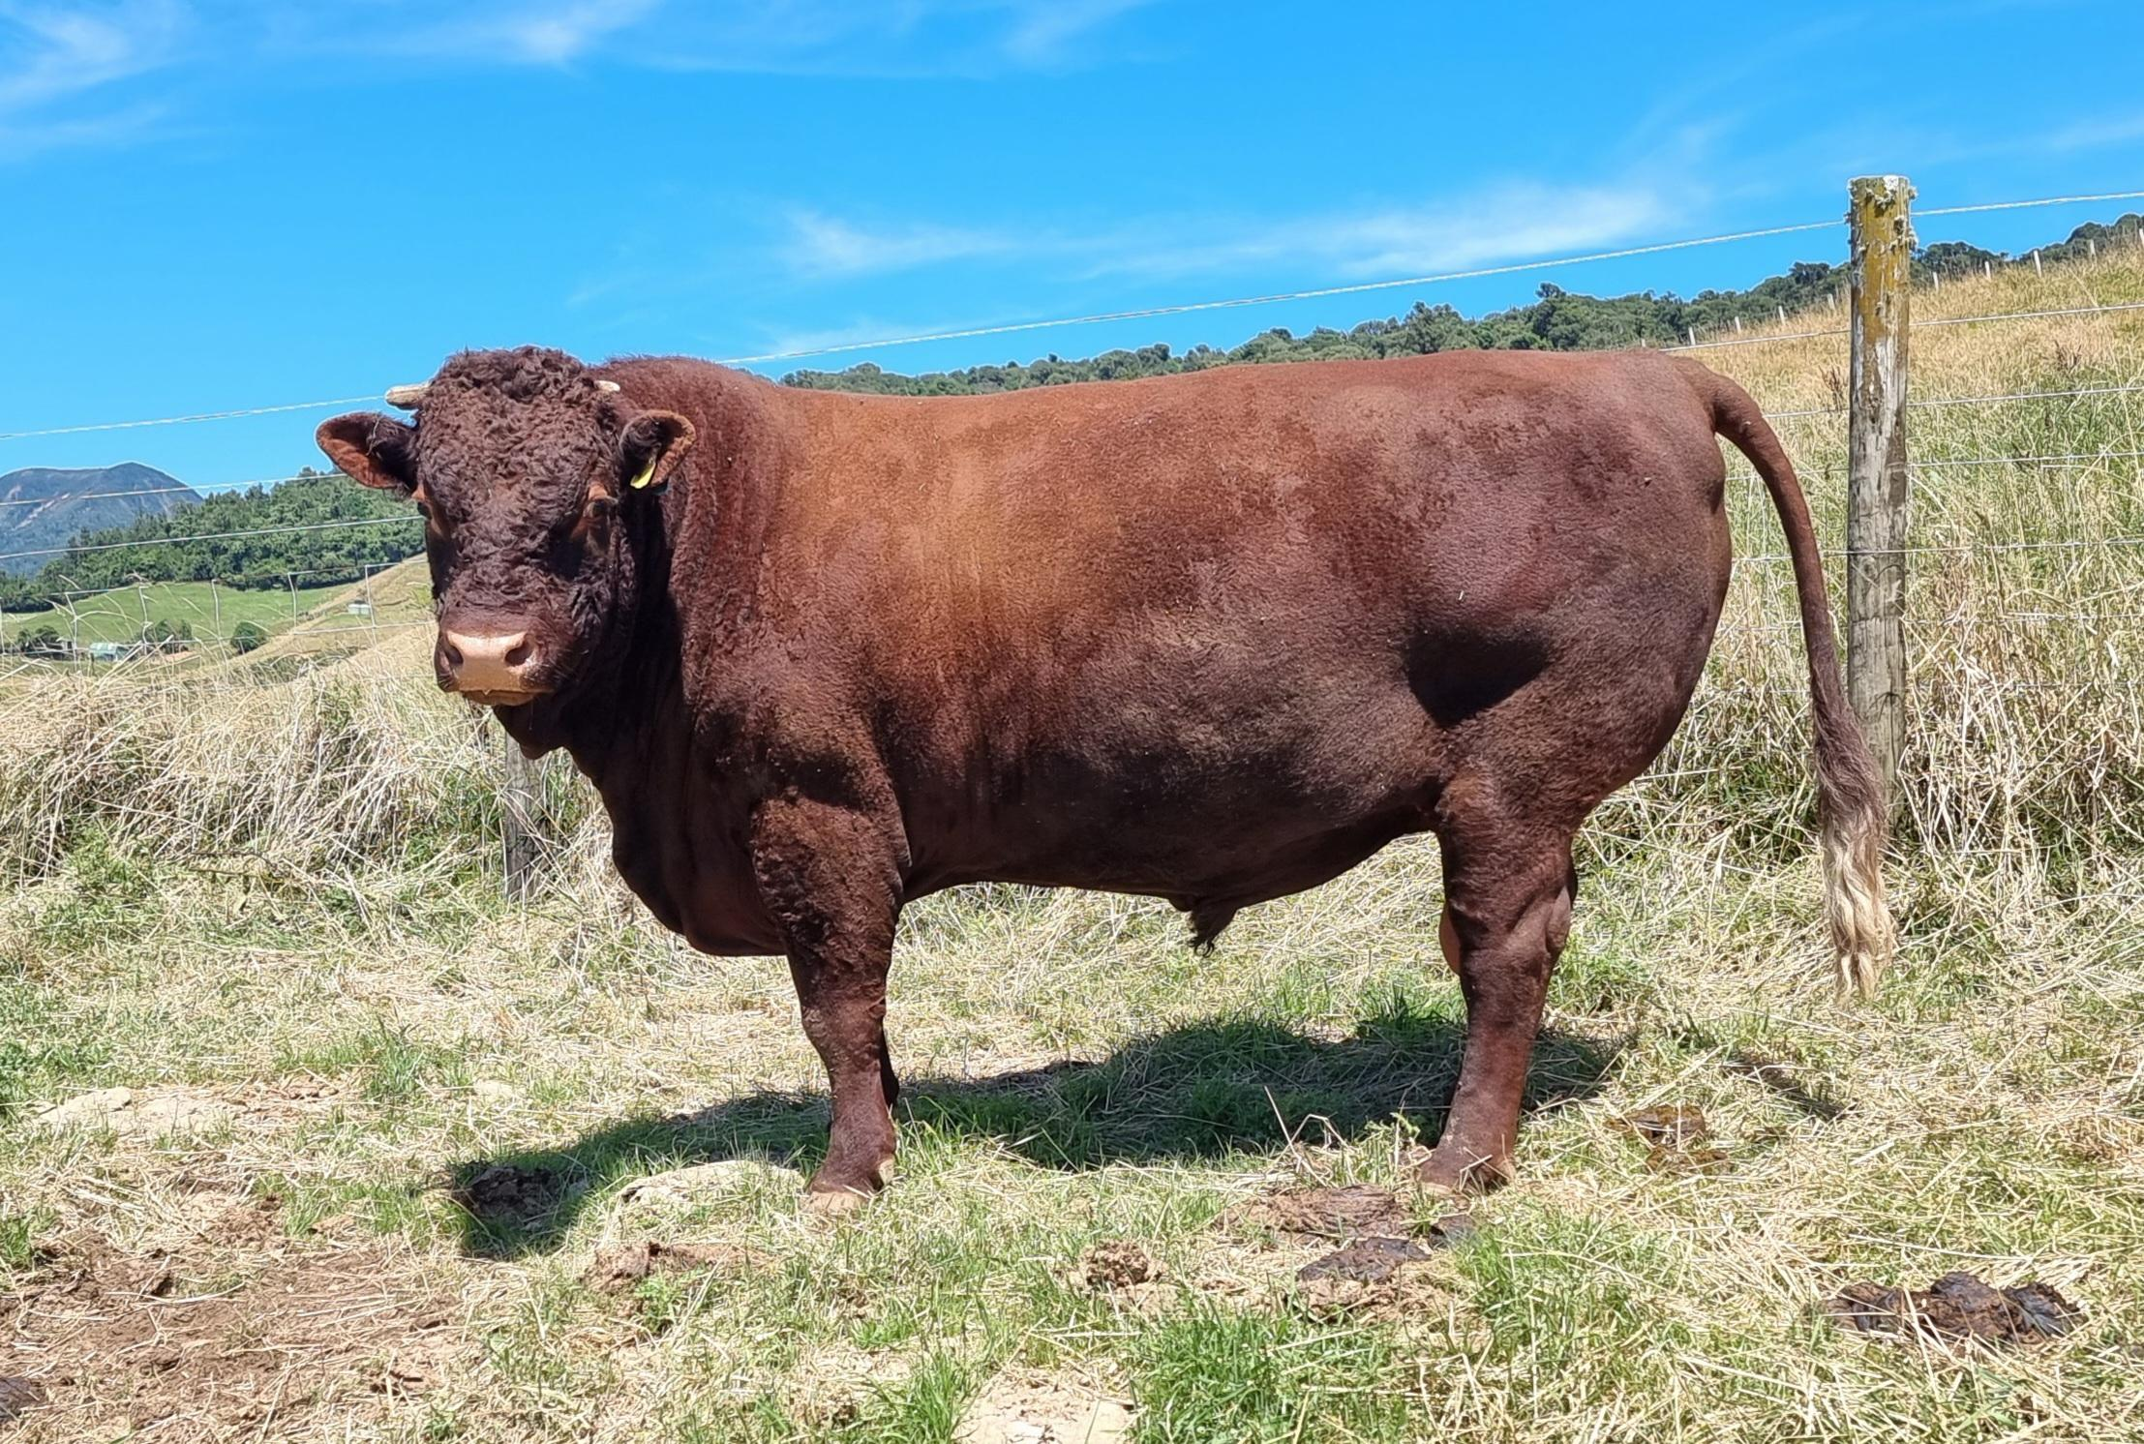

I would like to remind our members that their animals for sale can be mentioned in the newsletter, just contact me on dirk@sieling.nz with pictures and details.

Any member wishing to organise a stud visit in March should also get in touch. There is no stud update this time as none were supplied.

COUNCIL:

Heughan Gordon |  | Ph. 027 874 6195 |  |  | hcgordon@xtra.co.nz
Dirk Sieling |  | Ph. 021 154 0123 |  |  | dirk@sieling.nz
Lesley Holdstock |  | Ph. 03 329 0093 |  |  | trev_holdstock@yahoo.com
Jarred Sircombe |  | Ph. 027 485 2733 |  |  | mmreddevon@gmail.com
Vacancy
Stephen Harris |  | Ph. 07 880 9955 |  |  | savkharris@yahoo.co.nz
 | Lindy Lawrence |  | Ph.:  Mail:  e-mail: | 06-323 4484 / fax: 06-323 3878  PO Box 503, Feilding.4740  lindy@pbbnz.com


Members List (click here)

Important Dates to Remember
30th September | Annual animal pre-list dam fees invoiced
31st December | Balance Date; end of financial year
31st January | Calf entry sheets cut off
30th April | Membership Subscriptions Invoiced
May 2023 | AGM
30th June | Animal Disposal List (ADL) sent out
30th July | Deadline to return ADLs, by post or email to Lindy Lawrence at PBB lindy@pbbnz.com  Please note no cow credits for ADL’s returned after the 15th August
10th August | Calf Entries start
2nd of every month | Group Run Cut off for the performance recording reports
www.reddevoncattle.co.nz


