June 🏶 2025
New Zealand
RED DEVON
Cattle Breeders Association

Welcome to the June Newsletter

AGM

Text and photographs by Steve Harris

On the 10th of May those of us that could, attended the AGM at Dirk and Kathy Sielings 710 hectare Ohuka Farm Whitianga.

My wife Angela had done a stellar job booking us in to Bayside Motel whose location was within walking distance of Ohuka Farm Drive. We had escaped a front covering the Waikato the previous afternoon and woke up on Saturday morning to clear skies, and the promise of a warm sunny day which was duly delivered.

A small group of us convened at Dirk and Kathy's house for morning tea and enjoyed the pre-AGM banter whilst being easily distracted by the sea view down the valley. The AGM itself was also viewed by Zoom, and proxy votes had been sent in by a number of breeders who couldn't attend. After the Chairman and Financial reports, we fine-tuned the requirements for DNA testing, rising fees, registrations and promotions.

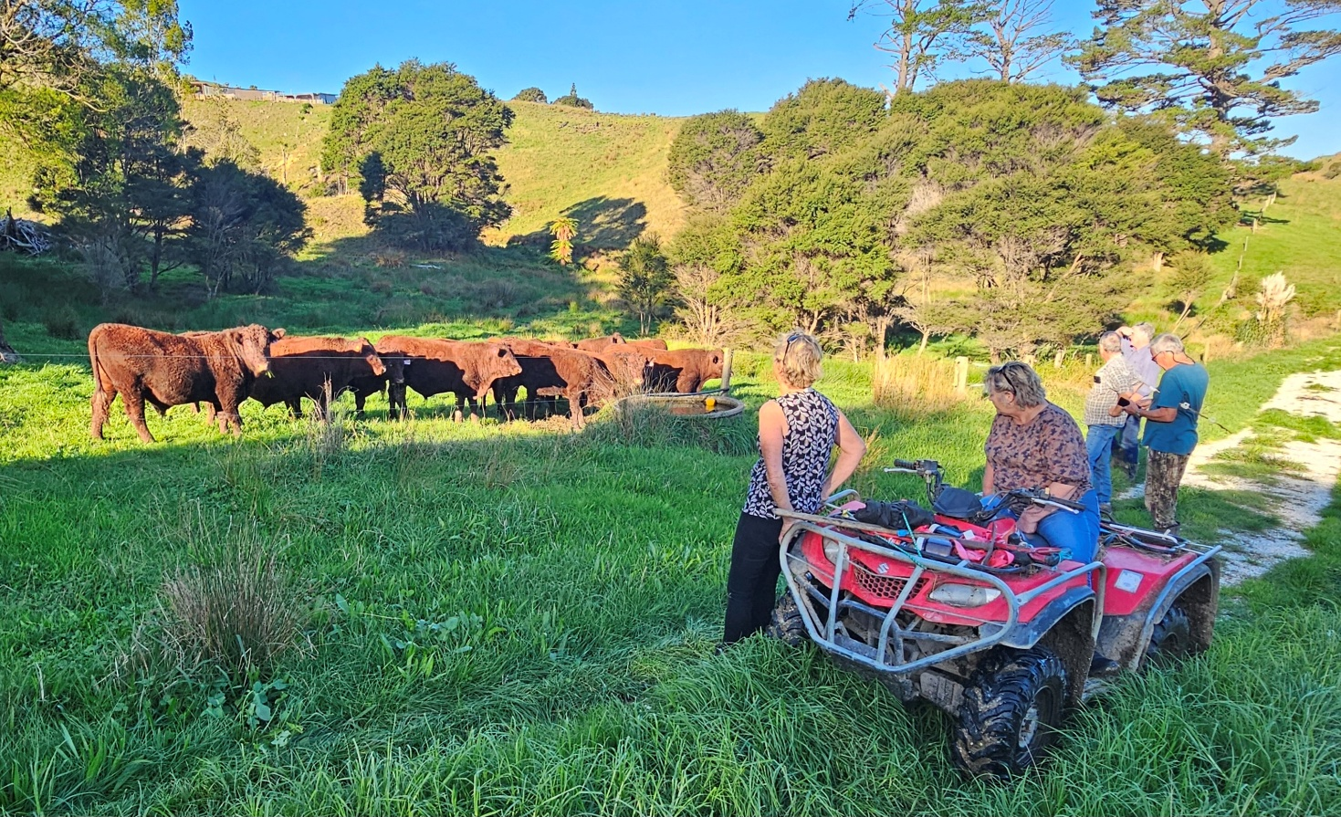

On conclusion of the meeting we had lunch al fresco as the day had warmed up aided by the Ohuka homestead’s location being in a micro climate.
Refreshed we set off on a farm walk starting with a group of mixed aged heifers gathered in a spot below the house, and from there we walked down to see the aging Tinopai BA Ryda sunning himself in his own small paddock. We then progressed to the cow herd with their Autumn born calves waiting for a shift to their next paddock, followed by a bunch of rising 2 year old bulls, and a group of 16 yearling bulls. Lastly we viewed home-bred sire Ohuka RW Nico biding his time before being re- introduced to the herd.

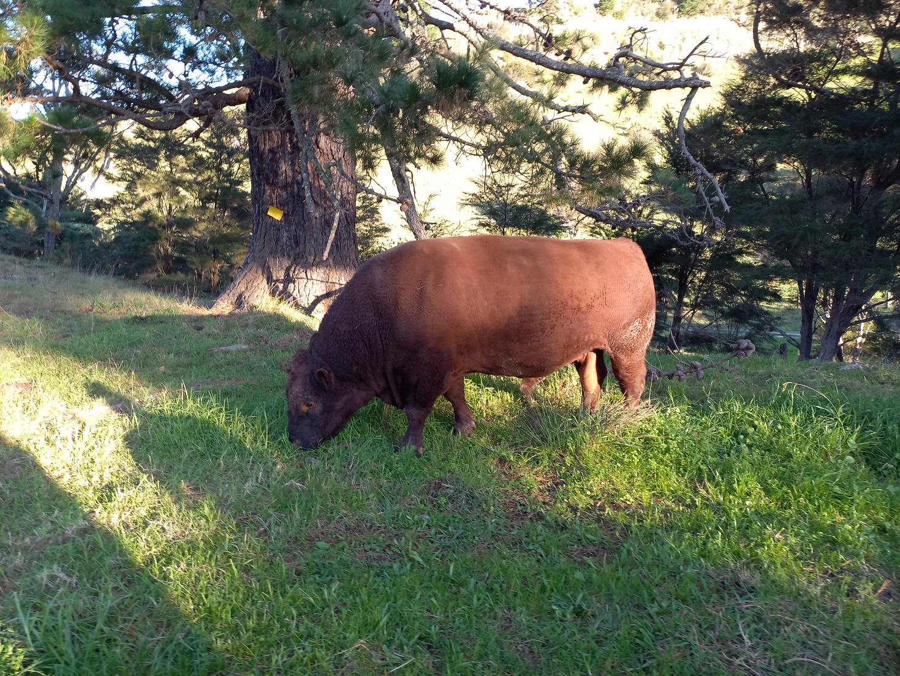
The management of the herd is based around the sub-tropical coastal climate which is the reason for calving in autumn. Calves are weaned at the start of summer, and graze paddocks ahead of the cows which are used to clean up the rough grass, and the fresh autumn regrowth provides quality grass to calve on. Bulls are sold at 18 months so avoiding grazing them through a second winter, a few of the best bulls are retained to lease out or sell to Association breeders.

Dirk's policy is to breed outcross sires from bought in females endeavouring not to exceed 5% inbreeding, using 3 to 4 mating groups to achieve this. The aim is to use bulls that have the potential to add to the ethos of the herd, notably light birth weight, docile and structurally sound bulls bred for dairy heifer mating. The overall impression is that the 45-50 strong autumn calving cow herd (which will rise to 60 in number going to the bull shortly) and followers has to perform on challenging rolling to steep country. To confirm that assumption, Dirk showed us the recently cleared forestry ground which had been over sown with grass seed by helicopter and fertilised with Sulphur coated Urea and Superphosphate.

After fencing the land into paddocks and providing water from the nearest spring, the older bulls are put in to give the resulting new pasture its first grazing. We drove on up to the top of the forestry block just below the 252 meter high point of the farm where the logs had been loaded out from, driving on an excellent farm road. The road was constructed from rock found on the farm and capped with crushed mussel shells weathered in a stock pile after being delivered from the processing plant, a perfect end use for an industry waste by-product.

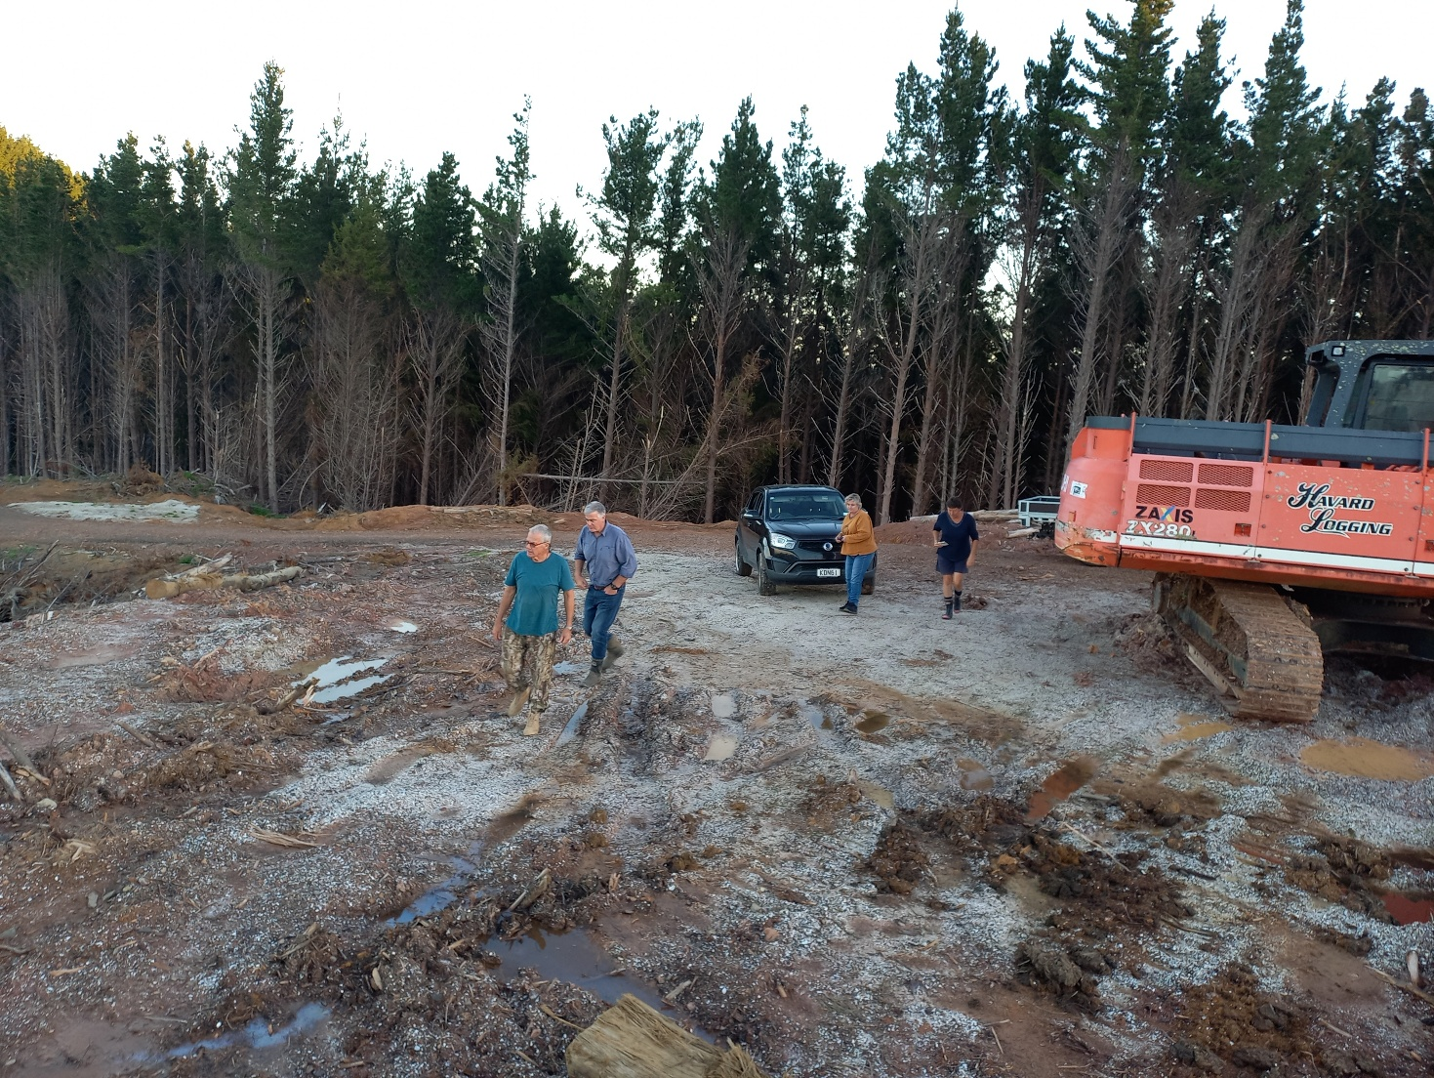

The view back to the coast was impressive but also highlighted the requirement for fit active cattle on the demanding contour. The forestry on the farm is gradually being turned into productive grazing, but a large proportion of the remaining bush covered hills will remain and may potentially be covenanted for the benefit of the local community. This also provides a source of pig hunting for Dirk to exercise his dogs and continue a longtime hobby, Kathys passion being her horses.

The aim of post AGM farm walks is to get the essence of a property and how a herd integrates with the environment, but it also provides a chance to catch up with other breeders and potentially come away with an idea, tip or trick as a bonus. Our thanks to Dirk and Kathy for a memorable day, and in mine and Angela's case an opportunity to visit a part of the country that we wouldn't normally travel to, it has whetted our appetite to see more of Whitianga and the Coromandel Coast.

DNA Reminder

Remember that from now on all calves entered for registration have to be accompanied by the sire’s DNA test. When purchasing or leasing a breeding bull from another stud make sure to get confirmation that a DNA certificate has been registered with the association or if using your own bull make sure to get it DNA tested. Exemptions due to exceptional circumstances can be granted by Council

UK Website

Below are the instructions to access the UK Red Devon website for those who want to check out ancestries.

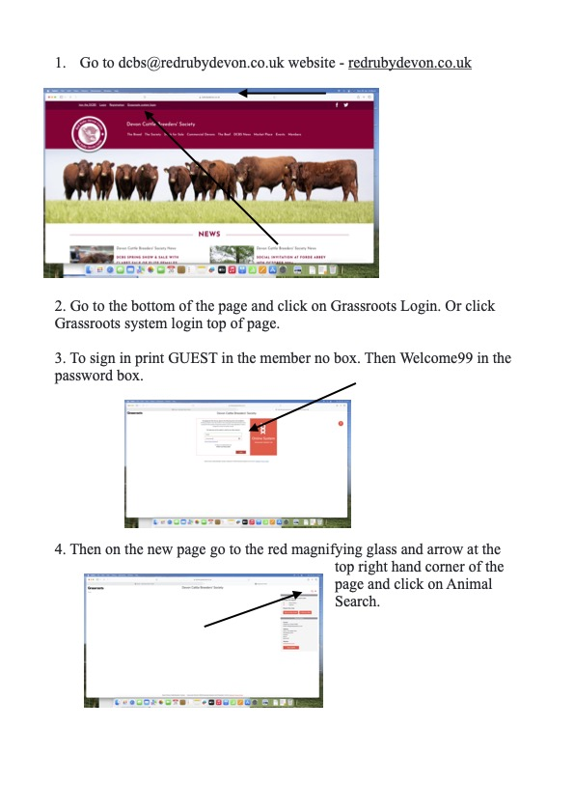
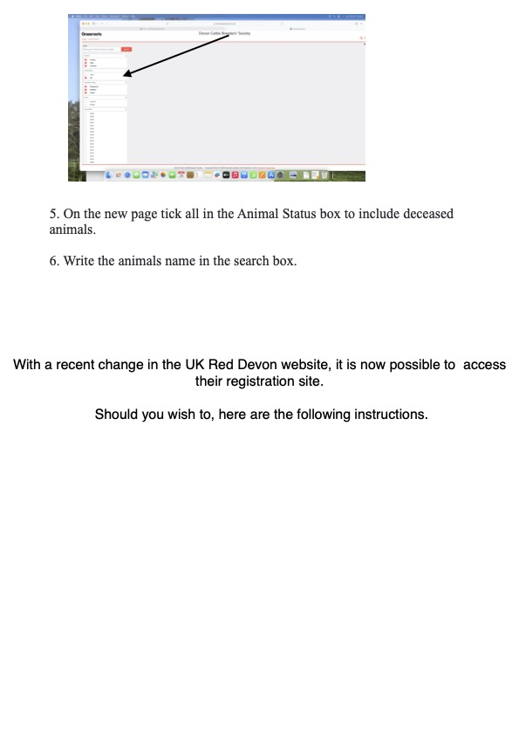

COUNCIL:

Heughan Gordon |  | Ph. 027 874 6195 |  |  | hcgordon@xtra.co.nz
Jarred Sircombe |  | Ph. 027 485 2733 |  |  | mmreddevon@gmail.com
Lesley Holdstock |  | Ph. 03 329 0093 |  |  | trev_holdstock@yahoo.com
Stephen Harris |  | Ph. 07 880 9955 |  |  | savkharris@yahoo.co.nz
Colleen Hunter |  | Ph 0210479471 |  |  | reddevonbeef@hotmail.com
For newsletter material contact:
Dirk Sieling |  | Ph. 021 154 0123 |  |  | dirk@sieling.nz
 | Secretary: Lindy Lawrence |  | Ph.:  Mail:  e-mail: | 06-323 4484 / fax: 06-323 3878  PO Box 503, Feilding.4740  lindy@pbbnz.com

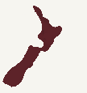
Members List (click here)

Important Dates to Remember
30th September | Annual animal pre-list dam fees invoiced
31st December | Balance Date; end of financial year
31st January | Calf entry sheets cut off
30th April | Membership Subscriptions Invoiced
May 2023 | AGM
30th June | Animal Disposal List (ADL) sent out
30th July | Deadline to return ADLs, by post or email to Lindy Lawrence at PBB lindy@pbbnz.com  Please note no cow credits for ADL’s returned after the 15th August
10th August | Calf Entries start
2nd of every month | Group Run Cut off for the performance recording reports
www.reddevoncattle.co.nz


