March 🏶 2025
New Zealand
RED DEVON
Cattle Breeders Association

Welcome to the March Newsletter

AGM

First up there has been a change in AGM venue. It has been harder than usual to find a stud that was keen on a visit and Council decided in the end to use the fallback position of Ohuka Polled Devon stud in Whitianga. The AGM will be held there on May 10 with details to follow in the official notification to be send out by Lindy in the coming week or so. In order to save money the AGM will be at our house and followed by a stud visit in the afternoon. We have overnight accommodation for 1 couple at the house and wish to make this available in the first place to any South Island members prepared to make the trip North. Contact me on 0211540123.

For those who have visited Ohuka in the past, there are some significant changes. After halving the original herd size we are now in expansion mode with the herd bigger than ever before. Autumn calving 32 registered cows and 10 registered heifers. Currently there are 4 herd sires. Apart from the previous influence of Bongalabi Atlas and Vix Jurassic there is some Tilbrook offspring and 2 previously used homozygous bulls bred by Tapuwae are starting to make their impact on the herd. There will be an additional 22 yearling heifers, 15 yearling bulls and half a dozen two year old bulls on show. The younger bulls are available for sale or lease with a couple of outstanding two year old homozygous polled leggy bulls with great conformation.

DNA Reminder

Don’t forget that all animals submitted to the association for registration after June 1 must have a DNA profiled sire. So that could be a sire of which a DNA profile is already held by the association or it may mean obtaining a DNA profile as outlined in a previous newsletter. Council has the power to make some exemptions for special circumstances. The proposed final wording of the rules will be provided prior to the AGM

ABRI

Jarred and Lesley met up with ABRI representatives to discuss the clunkiness and user unfriendliness of the ABRI registry. Hopefully there will be some improvements!

Our Website

From Lesley

As a member of the Association one of the additions that members have is the opportunity to use the For Sale site.
Some members may not be aware that listing in this section has no charge tied to it.
The Website is also open for non-members/visitors to access so this can be a worthwhile window for offering up any Red Devon stock that you may plan to sell.
There also is no time limit on how long your listing will be shown, basically until your stock offered have been sold.

Compare this to a startup charge of $60 or so if you go look at Trademe's prices, with extras on top if you would like additional wording on the main listing title, with Trademe contacting you to renew every two weeks.

The Facebook Page -
The Red Devon Association Facebook page is your page.
Topics (hopefully) of interest are posted on this site on a reasonably regular basis, this Facebook site now has 142 followers (at the last count on the 28/1/2025) this has taken at least 18mths to attract, which is now, an audience Worldwide along with a home audience.

You are able to visit this page and post as a visitor, or alternatively information along with plenty of useable pictures can be sent to this email: trev_holdstock@yahoo.com and this information can be posted on the Facebook page for you.

What can you post you may ask ?
Anything really relating to the Red Devon breed of cattle.....Your favourite cow, the young calf that you have that you are totally delighted with and would love to share with others, your newly purchased herd Sire, or the older bull that you have been using for quite awhile and he's certainly worth a mention as he's great !!
A promotion of your Herd, a report on what's been happening on your farm with your Red Devons - in fact any subject that would be of an interest to other fellow Red Devon breeders and enthusiasts regarding the fabulous Red Devon breed.

Thank you, Lesley.....Ellesmere Red Devons.

Stud Report

From Wickton Red Devons

As I wrote, we here on the outskirts of Matamata in the Waikato, were receiving welcome rain. Our last 3 months have been drier than normal. Also relief from the frequent watering of young fruit trees in our newly established orchard. We were due a dry summer, and it’s good in a way to have one, so that I can identify the carrying capability of our 68 acres. At this stage it looks like 25-28 cows with all the young stock raised, and mature cattle fattened, is comfortable in an adverse year. We normally make all supplements on farm but if we have to buy anything in, I like hay with as many deeper rooted species in a bale as possible. Cocksfoot, fescue, prairie grass, red clover etc are preferable to straight ryegrass and white clover which is too fickle for our sandy soils, giving up easily when the heat goes on (literally). Our policy of no fertilisers, sprays or wormers, and only BVD and Leptospirosis vaccinations with trough minerals has meant that our aim of developing a herd of no fuss resilient cattle is progressing well. The Devons were made for regenerative grazing with their impact gradually improving the farm’s ability to cope with extremes. On the genetics side, it is still a work in progress with certain lines showing dominance, and a superior ability to perform. As a consequence we are developing a type that suits our environment. We assess the herd regularly and cull for a number of traits , be it poor feet, constitution type, fertility, milking ability etc and the beauty of Red Devon cattle is that they fatten easily and command a good return at either the yards or meat works. A couple of criteria that I believe will become more important are, the ability for an animal to quickly shed it’s winter coat in spring and develop a slick summer coat, which is part of the process of the other trait I am looking for, heat tolerance. We are always trialing fresh genetics, having our own flask and me doing the AI is useful, and the resulting calves make an interesting comparison with our existing breeding. The herd was established primarily to produce cattle for fattening and thus avoiding buying in cattle that may carry health issues, or trading on an unpredictable market. The result is we rarely sell surplus females or bulls for breeding. This may change with demand, but our current stock policies suit just fine.

Steve Harris

Below the sunrise shot are pictures of Brightly Diamond 6 bull calf and its dam as well as herd sire Wickton Intrepid and Steve Harris

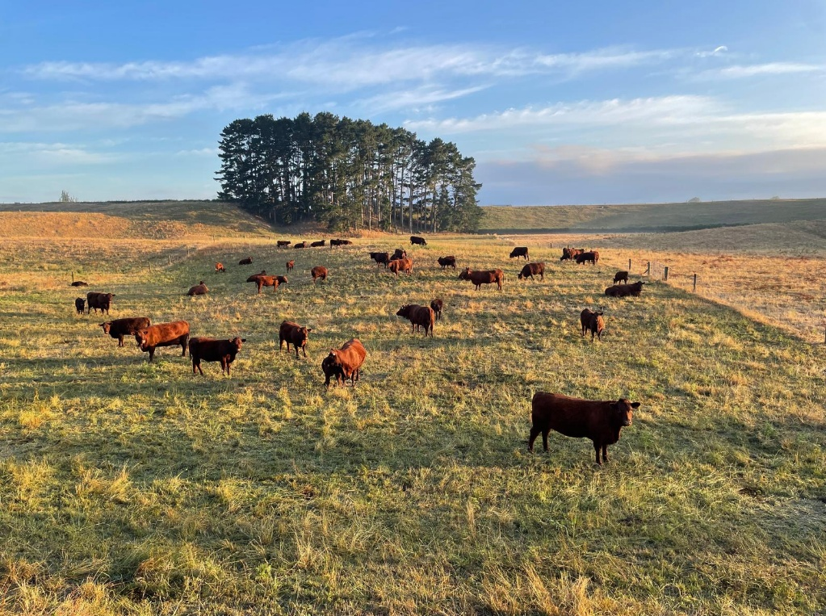

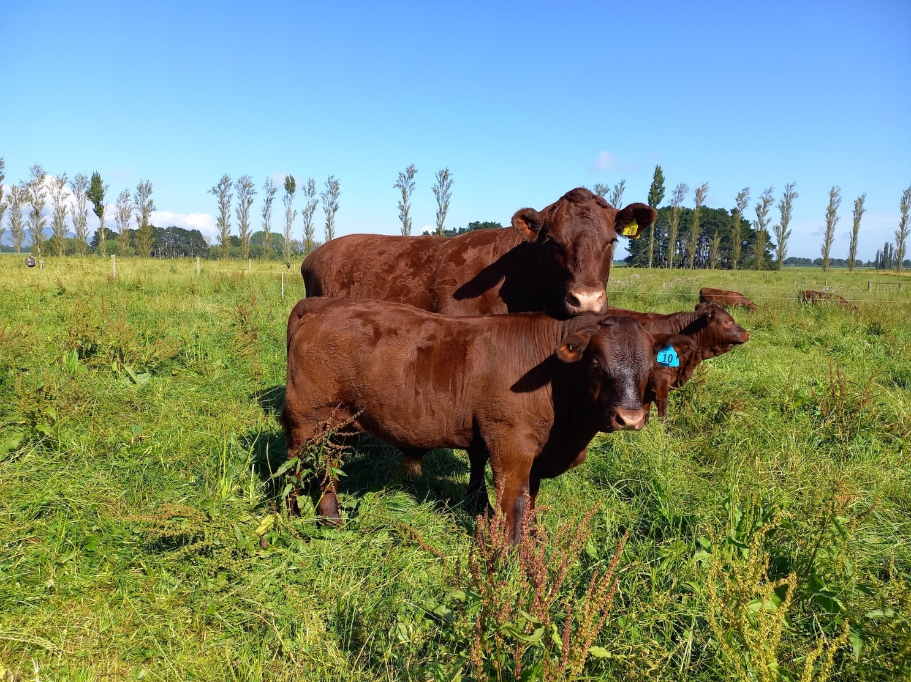
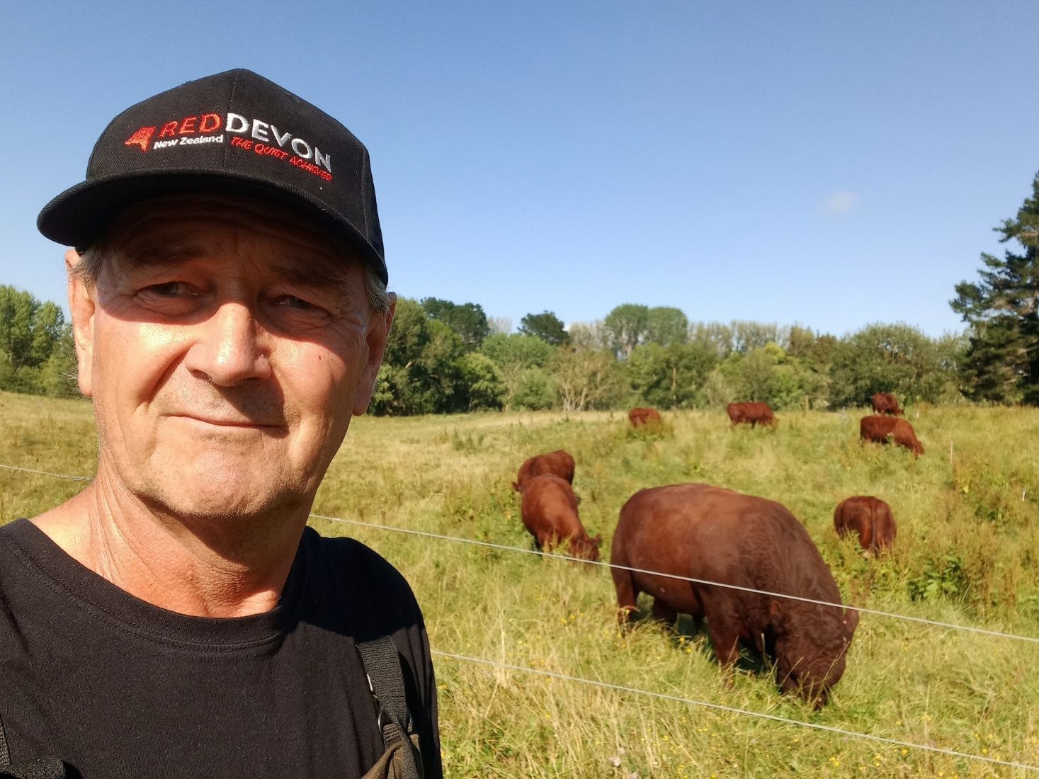

That’s your newletter for March, hope to see you at the AGM

COUNCIL:

Heughan Gordon |  | Ph. 027 874 6195 |  |  | hcgordon@xtra.co.nz
Jarred Sircombe |  | Ph. 027 485 2733 |  |  | mmreddevon@gmail.com
Lesley Holdstock |  | Ph. 03 329 0093 |  |  | trev_holdstock@yahoo.com
Stephen Harris |  | Ph. 07 880 9955 |  |  | savkharris@yahoo.co.nz
Colleen Hunter |  | Ph 0210479471 |  |  | reddevonbeef@hotmail.com
For newsletter material contact:
Dirk Sieling |  | Ph. 021 154 0123 |  |  | dirk@sieling.nz
 | Secretary: Lindy Lawrence |  | Ph.:  Mail:  e-mail: | 06-323 4484 / fax: 06-323 3878  PO Box 503, Feilding.4740  lindy@pbbnz.com


Members List (click here)

Important Dates to Remember
30th September | Annual animal pre-list dam fees invoiced
31st December | Balance Date; end of financial year
31st January | Calf entry sheets cut off
30th April | Membership Subscriptions Invoiced
May 2023 | AGM
30th June | Animal Disposal List (ADL) sent out
30th July | Deadline to return ADLs, by post or email to Lindy Lawrence at PBB lindy@pbbnz.com  Please note no cow credits for ADL’s returned after the 15th August
10th August | Calf Entries start
2nd of every month | Group Run Cut off for the performance recording reports
www.reddevoncattle.co.nz


